For information on Retention data, please use this data guide:

<https://uirr.iu.edu/doc/resources/ir-data-guides/IR%20Retention%20tables.xlsx>

Other data guides about student data are available on the UIRR/IA index page: https://uirr.iu.edu/resources/ir-data-guides/index.html

UIRR/IA Interactive Tableau Reports: <https://uirr.iu.edu/facts-figures/outcomes/index.html>

<https://ds.iu.edu/> - search for Retention for other interactive reports

Basic Overview of IR_RETN_GT (the dss/iuie comprehensive retention view)

IR_RETN_GT is an IUIE/DSS view that contains retention data for students with a first term enrolled as a degree-seeking student for Fall 2006 or later, whether beginner or transfer students. It also contains students in all careers. If a student is in an official IPEDS cohort (ie, Fall 2020 beginners), they will have a retention ‘stack’ of 20 term records for the institution where they began in that cohort. If they transferred to another campus, they would also have a stack of term records at that new institution, beginning in that first term at that campus, for 20 terms.

The view contains one row per university id/home campus/career/term. The first enrolled term is loaded into the view with a sequence row of 1 and a status of enrolled. For each subsequent fall or spring term (for 20 terms), that next term row is added, incrementing the sequence number by 1, and updating the status to indicate enrolled, degree or not enrolled, and also updating any retained indicators (to 1 for retained or 0 for not retained).

The metadata document linked above, contains a description of every column in the view. It is very comprehensive, providing options to look at term statuses within just the home campus, or at any IU campus, to see if a student transferred to another non-IU institution, if they had a service indicator that prevented re-enrollment. There are many first term attributes that you can filter by (example: sex, ethnicity, residency, level, and many others).

**Notes**

* It is highly recommended that your first use of this data be to download just a 100 row sample, and review the data for a solid understanding for how it works, before trying to download your full dataset.
* Be aware of your parameters and additional criteria. If you do not set these values properly, you may get a dataset that is too large to work with. If you know you just want to look at fall to first spring retention, you could have a smaller dataset by using either of the sequence parameters (depending on your needs), and only return sequences 1 and 2. For fall to second fall, return sequences 1 and 3. By learning more about the data, you can manage the size of your data output.
* For SQL users who run queries directly in dss1prd, we can provide sql similar to what we use for submission of official retention and graduation rates to IPEDS.

If you have further questions, please contact [uirr@iu.edu](mailto:uirr@iu.edu)

Below is a basic beginner’s guide to using Retention data in the IUIE:

In the IUIE, search for IR_RETN_GT , you will see this interface after selecting the report. Please note, it is possible there may be additional parameters listed than what you see below if parameters have been added since the update of this document. If other parameters would help limit your population, but are not in the parameter list, please email your request to uirr@iu.edu:

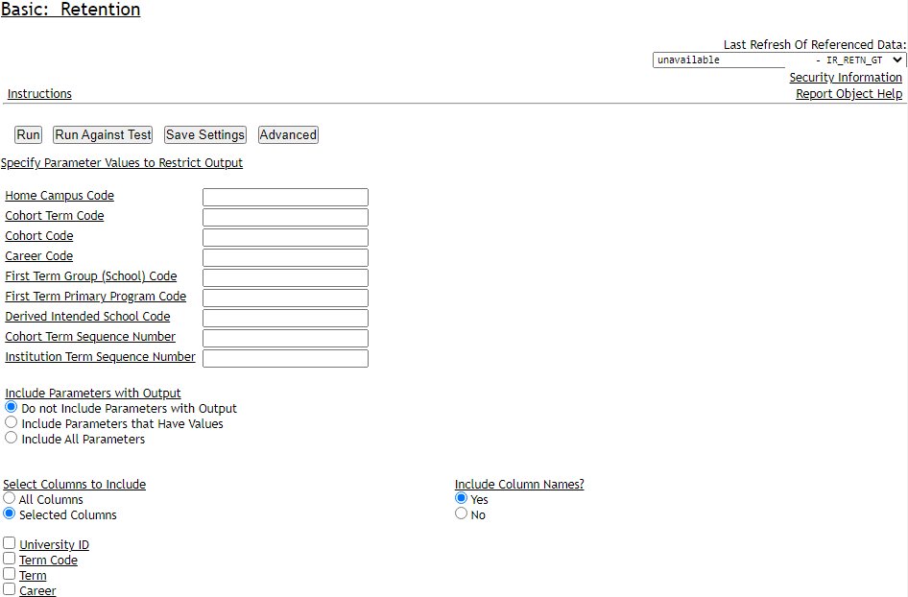

There are some parameters to allow you to select a population.

Home Campus Code – IUBLA, IUINA, IUCOA, IUFTW, IUEAA,IUKOA,IUNWA,IUSBA,IUSEA – the campus where a student began their degree-seeking career.

Cohort Term Code – the term that a student began as a degree-seeking student. Ie, 4228 (Fall 2022)

Cohort Code – a derived value describing a student’s cohort. The format is TYYZZA where

T=F if the student began in Fall, S if in Spring

YY=the year

ZZ=describes the career (UG,GR,MD,LW,OP,DT)

A=beginner or transfer (B or T)

Examples:

F22UGB=fall 2022 undergraduate beginners

F22UGT=fall 2022 undergraduate transfers

F22GRB=fall 2022 graduate beginners

F22LWB=fall 2022 law beginners

There are other ways to limit your population. For example, if you would like to only pull students in a particular student group, you can:

Click the Advanced button (near the top)

In the additional criteria box , enter SQL similar to this (you will need students records to access SR_STU_GRP_ACTV_INACTV_GT, which can be requested via the IUIE):

prsn_univ_id in (select prsn_univ_id

from dss_rds.SR_STU_GRP_ACTV_INACTV_GT

where stu_grp_cd in ('VHHS')

)

**note** what is highlighted in yellow can be modified to be any group(s) you are interested in. You can add multiple group codes by separating them with a comma, and using single quotes around the value, ie: stu_grp_cd in ('VHHS', 'ATHL'). Note, if you use multiple values in this list, you will not be able to identify which group a student who is returned in your dataset is in. If that is needed, only include one value in the SQL for each run.

Click the All Columns radio button and scroll down to the bottom (this will return all columns based on the parameters or additional sql you provided to limit your population)

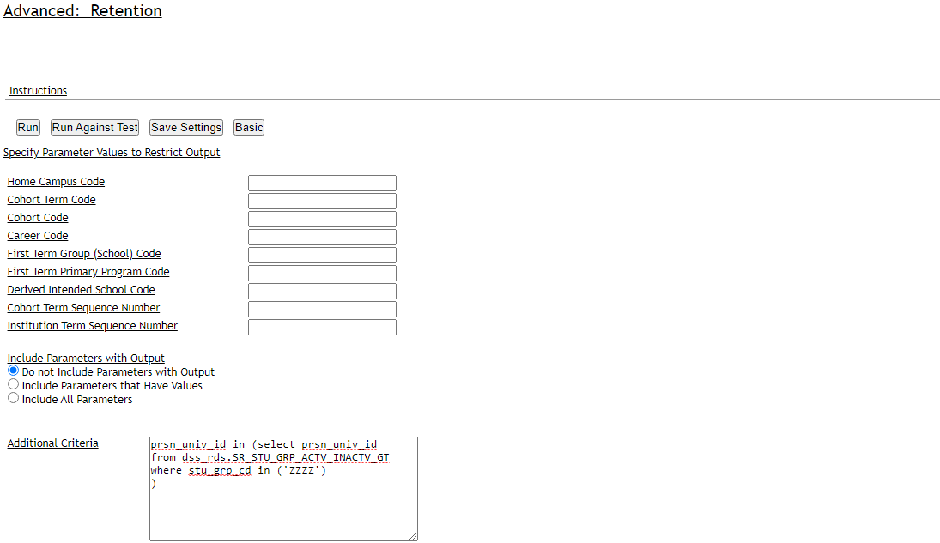

Scrolling down, I would recommend these output options:

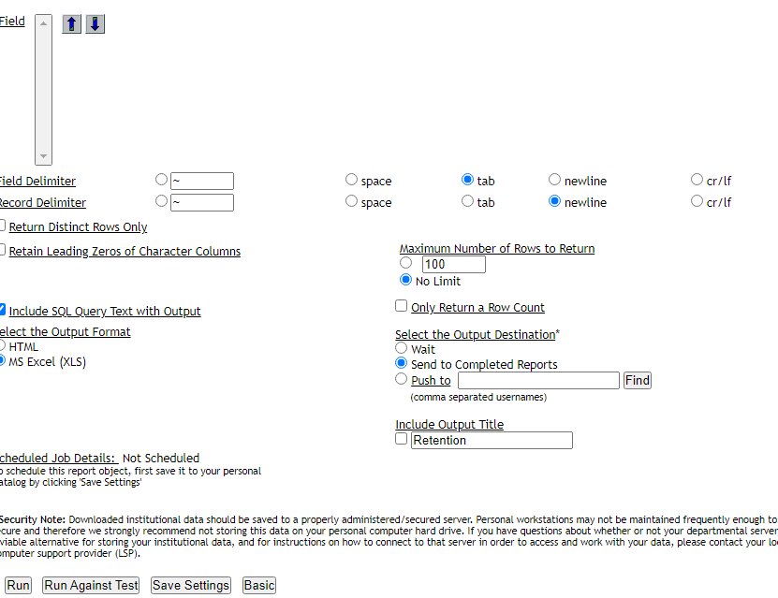

You will get an email with a link to the spreadsheet of results.

To answer your retention questions using the returned spreadsheet, see examples below.

Remember, you can view data about every column in the view here (use the tab IR_RETENTION_GT, it has the same columns as IR_RETN_GT)

<https://uirr.iu.edu/doc/resources/ir-data-guides/IR%20Retention%20tables.xlsx>

Examples of using the returned retention dataset. You will be using Excel, so you will want to be proficient in sorting, filters, and pivot tables. The scenarios below describe the columns you will use for filtering and using the data. A pivot table is your best tool for looking at the beginning population (using a cohort code(s), one of the sequence columns, retained indicators, statuses…).

1. For Fall21 to spring22 retention rate for fall beginners.

Filter the Cohort Code column to the value F21UGB

F21UGB is Fall 2021 Undergrad Beginners, so beginning undergraduates who began their first degree-seeking term in the Fall 2021. If you need other than the strict fall beginners, we may need to discuss.

Filter the Cohort Term Sequence Number column to 2

You would see the Term Code value for these rows should be 4222 (since 4218 would have been on the sequence 1 row)

Now, you can use a status column to see how many were retained.

IU Status Code gives you a status based on any IU campus (ie, they may have been at BL in term seq 1, and IUPUI in seq 2). The IU status would be ‘E’ for enrolled.

Home Campus Status Code for that same student would be N for Not enrolled since they are not enrolled at the starting campus of BL.

BA Seeking (IU/Home) status code will show enrolled or degree only if at the bachelor’s degree level (it excludes certificates and associates degree students)

Retained at IU Indicator (as well as other retained indicators, each with different purposes, see metadata document) can be used to sum the number of students retained in a particular term (seq) in your pivot table. Any of the retained indicators will have a value of 1 if the student is retained (either enrolled or degreed) for the term, and a 0 if not retained. Once a student receives a degree, that retained value of 1 is carried forward to all future terms.

*Note* There is a column called ‘exclusion indicator’. For official reporting, if a student dies or leaves for a military service, this column will contain a value of XD or XM. In these cases, we would exclude these students from the population and they would not be counted in the retention figures.

1. Fall21 to Fall22 retention rate.

Similar to above, but

Filter the Cohort Term Sequence Number column to 3

You would see the Term Code value for these rows should be 4228 (since 4218 would have been on the sequence 1 row)

1. The six-year graduation rate of the fall 2015 freshmen cohort. Graduation rates get a little more complicated.

Filter the Cohort Code column to the value F15UGB

F15UGB is Fall 2015 Undergrad Beginners, so beginning undergraduates who began their first degree-seeking term in the Fall 2015.

Filter the Cohort Term Sequence Number column to 13

You would see the Term Code value for these rows should be 4228.

There are many columns you may be interested in depending on what type of graduation rate you are interested in calculating:

The IU Status Code and Home Status Code may still be relevant to you if you just want to see the number of degrees received after 6 years. Retained at IU Indicator will sum to the number of students retained based on your pivot table.

BA Seeking (IU/Home) status code will show enrolled or degree only if at the bachelor’s degree level (it excludes certificates and associates degree students)

*\*\*Note** Degrees are reflected in the term after they receive a degree. For example. Student enrolls for their first term in Fall 2018, their status code is E. They enroll for the next 7 terms, and each of those statuses are also E. In Spring 2022, they receive their BA degree. The spring 2022 term status is E, since that is their status for that term. Their status for Fall 2022 is now D since they have received their degree.*

The columns we use for reporting official graduation rates are:

Education Level for 150 Percent Degree Completion Time – Official – this will contain ‘4’ is the student received a bachelors’ degree within 6 years, ‘2’ if the student received an associates degree in 3 years, a ‘1’ if they received a certificate in 1.5 years. Otherwise it will be blank.

4. The four-year graduation rate of the fall 2015 freshmen cohort.

Filter the Cohort Code column to the value F15UGB

F15UGB is Fall 2015 Undergrad Beginners, so beginning undergraduates who began their first degree-seeking term in the Fall 2015.

Filter the Cohort Term Sequence Number column to 9

You would see the Term Code value for these rows should be 4208.

There are many columns you may be interested in depending on what type of graduation rate you are interested in calculating:

The IU Status Code and Home Status Code may still be relevant to you if you just want to see the number of degrees received after 4 years.

BA Seeking (IU/Home) status code will show enrolled or degree only if at the bachelors degree level (it excludes certificates and associates degree students)

The columns we use for reporting official graduation rates are:

Education Level for 100 Percent Degree Completion Time – Official – this will contain a ‘4’ if the student received a bachelors’ degree within 4 years, a ‘2’ if the student received an associates degree in 2 years, and a ‘1’ if they received a certificate in 1 years. Otherwise, it will be blank.

I highly recommend reviewing the columns in the metadata spreadsheet linked at the top. And if you have questions as to how we would use any of them, please ask, [uirr@iu.edu](mailto:uirr@iu.edu)

Optional:

Instructions for updating your dss1prd password so you can directly query dss1prd:

<https://kb.iu.edu/d/axaq>

Configuring your Oracle sql tool of choice (ie, SAS) to access dss1prd:

<https://kb.iu.edu/d/beaw>